FLORIDA FOLKLIFE APPRENTICESHIP PROGRAM
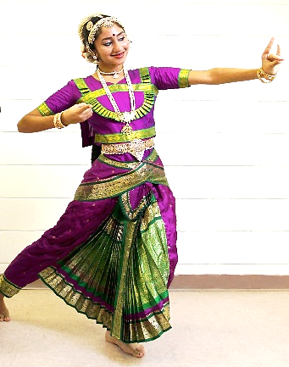
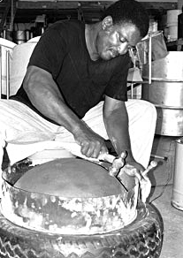
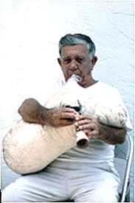
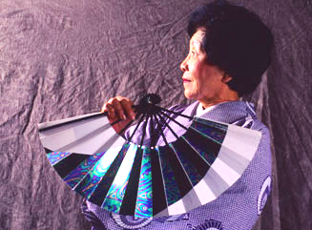
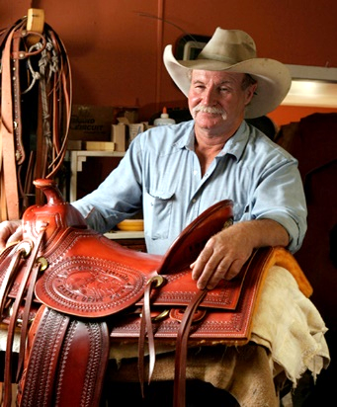
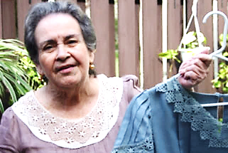
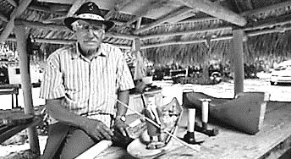
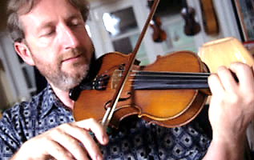
GUIDELINES AND APPLICATON
Top left to right: Michael Kernahan, steel pan drums; Kazuko Law, Japanese dance; Nikitas Tsimouris, Greek tsabouna; Mike Wilder, saddles; Center: James Kelley, Irish fiddle; Bottom left to right: Aida Etchegoyen, Puerto Rican mundillo lace; Bobby Henry, Seminole dugout canoes; Shree Sundaresh, Indian classical dance.

PROGRAM INFORMATION

The Florida Folklife Program documents and presents the folklife and folk arts of the state. Folklife consists of a complex body of traditions and shared knowledge that is passed on informally within folk groups.
Florida folklife is “… traditional expressive culture shared within the various groups in Florida: familial, ethnic, occupational, religious, and regional. Expressive culture includes a wide range of creative and symbolic forms such as custom, belief, technical skill, language, literature, art, architecture, music, play, dance, drama, ritual, pageantry, and handicraft, which forms are generally learned orally, by imitation, or in performance, and are maintained or perpetuated without formal instruction or institutional direction.” Section 267.021 (6), Florida Statutes

The Florida Folklife Program welcomes applications for apprenticeships in all forms of Florida traditional culture—from boat making to saltwater fly tying, from old-time fiddling to Afro-Caribbean percussion, from African American gospel steel guitar to Greek bouzouki, from Nicaraguan festival arts to Japanese dance, from steel drum making to Seminole basket making.

The Folklife Apprenticeship Program provides an opportunity for master folk artists to share technical skills and cultural knowledge with apprentices in order to perpetuate their valuable traditions. Master artists should be among the finest practitioners of the tradition in their communities. Apprentices must have experience in the tradition they wish to study, and must make a commitment to learn it thoroughly. The underlying purpose of the Florida Folklife Program is to reinforce traditions within a folk group; preference is therefore given to apprentices who study traditions within their own group. The Florida Folklife Apprenticeship Program is funded in part through a grant from the National Endowment for the Arts’ Folk & Traditional Arts Program.

GRANT AMOUNTS

Awards are available for eight-, six-, or three-month apprenticeships. Awards are intended to cover program expenses including all supplies and transportation. When apprenticeships are awarded to immediate family members (parents, siblings, or children) of the master artist, support is limited to materials costs or other program expenses on a reimbursement basis according to State of Florida allowable amounts.
DURATION | AWARD FOR MASTER | AWARD FOR APPRENTICE
3 month apprenticeship | $750 | $150
6 month apprenticeship | $1,500 | $300
8 month apprenticeship | $2,000 | $400

HOW TO APPLY

Eligibility

Interested masters and apprentices must apply as a team by submitting the joint application. Before completing the application, the master artist/teacher and apprentice should discuss their ideas for the apprenticeship. In this way, we hope you will come to a shared understanding of what will take place and why. Prospective apprentices and masters should discuss the pre-requisite level of skill, frequency and location of meetings, the work plan, and goals. Both should agree on training expectations. Apprentices must be permanent Florida residents, and it is preferred that masters and apprentices belong to the same folk group.

Completing the Forms

The master and apprentice must complete the attached application form. Part 1 is for the master, Part 2 is for the apprentice, and Part 3 is to be completed by both master and apprentice. Please answer all questions as thoroughly as possible and use additional pages as needed. Your information will be reviewed by members of the Florida Folklife Council, who will recommend successful applicants based on the information in the answers. Applications do not have to be typed, but should be legible. If you complete the forms by hand, please print and use black ink.

SUPPORT MATERIALS

Both masters and apprentices must include audio-visual work samples and written support materials as evidence of their abilities. They are an important part of the application package and will be presented to the Council for comment. Support materials should be appropriate for the art form you intend to teach. Professional recordings and videos are not necessary. Media materials of applicants chosen to participate in the program will be submitted to the Florida State Archives. Please refer to the following guidelines:

Audio-Visual Work Samples and Materials

- Crafts and Occupational Folk Arts:
Digital images are preferred. Please submit at least six (6) and no more than ten (10) images. It is best to show whole objects and examples of detail. Provide images that are in focus and not too dark or too light. Photographic prints or 35mm color slides are acceptable. Please label any slides with your name and indicate “top.”

- Music:
A video and/or audio sample up to ten (10) minutes in length is recommended. This sample can feature audio and/or video of a single work or selections from multiple works but cannot exceed ten (10) minutes in length. CD and/or DVD recordings and links to YouTube clips are preferred. Audiocassette tapes and VHS videos are acceptable but are more difficult to present to panelists. For best results, use a high-quality, name-brand disc or cassette and avoid high-speed dubbing. Include representative examples of your music. Recordings of unaccompanied performances are preferred.

- Dance:
A video sample up to ten (10) minutes in length is recommended. This sample can feature video of a single work or selections from multiple works but cannot exceed ten (10) minutes in length. A DVD recording or a link to a YouTube clip is preferred. VHS videos are acceptable but are more difficult to present to panelists.

- Storytelling and Oral Traditions:
A sample up to ten (10) minutes in length is recommended. This sample can feature audio and/or video of a single work or selections from multiple works but cannot exceed ten (10) minutes in length. CD and/or DVD recordings or links to YouTube clips are preferred. VHS videos and audiocassette tapes are acceptable but are more difficult to present to panelists. For audiocassettes, use a high-quality, name-brand tape.

- Written Support Materials
Two (2) or more letters of support attesting to the quality and authenticity of the master artist's skills are required. Letters from community leaders, colleagues, peers, cultural specialists, or other individuals who can confirm the details of the application and attest to the master artist's qualifications may strengthen an application. Please do not submit more than five (5) letters of support for the master artist. Letters of support for the apprentice are also encouraged; do not submit more than two (2) letters of support for the apprentice. Letters of support must directly address the current application to the Apprenticeship Program. Recommendation letters written for other activities, such as prior performances, educational activities, and festival demonstrations, may be submitted in support of the application but will not serve as letters of support; they will be considered general support materials. Press clippings of articles written about the master artist or apprentice may be included with the application but will not serve as letters of support. Please limit support materials, such as press clippings, performance programs, and festival flyers, to no more than ten (10) items.

APPLICATION DEADLINE

All applications must be postmarked by May 15, though we encourage you to submit an application before the deadline. If May 15 falls on a Saturday, Sunday, or legal holiday, the deadline date will be the next business day. Submitting an application before the deadline will ensure that you will have sufficient time to send any necessary materials not included in your original application.

Please send completed applications to:

Florida Folklife Program
Division of Historical Resources
500 South Bronough Street
Tallahassee, FL 32399-0250

If you have any questions about the application or need assistance, please contact Amanda Hardeman, State Folklorist, at the above address or at 850.245.6427 or 1.800.847.PAST. E-mail inquiries may be directed to Amanda.hardeman@dos.myflorida.com

SELECTION AND NOTIFICATION

All applications postmarked by the deadline will be reviewed by the Florida Folklife Council, which will make recommendations on the selection of apprenticeship teams to the Secretary of State. Final decisions will be made by August, and we will notify all applicants shortly thereafter.

REVIEW CRITERIA

The Florida Folklife Council will review each application and make its recommendations to the Secretary of State as to points awarded on a ten-point scale. Your application will be evaluated according to the following criteria:

- Expertise of the master artist. Work samples and letters of support will assist in determining the level of expertise.
- Level of commitment to the apprenticeship.
- Feasibility of the work plan and the overall coherence of the apprenticeship.
- Impact of the apprenticeship on the vitality of the tradition.
- Relevance of the tradition to the cultural history of Florida.
- Master and apprentice belong to the same folk group.

Form #HR3E23
March 27, 2014

PART 1: MASTER ARTIST

Name:
_____________________________________________
Address:
_____________________________________________
City, State, Zip:
_____________________________________________
E-mail address:
_____________________________________________
Telephone:
_____________________________________________

Birth date:
_____________________________________________
SS#
_____________________________________________
Tradition you wish to teach:
_____________________________________________
_____________________________________________
FL resident:____________ U.S. citizen:______________
If not, immigration status:
_____________________________________________

- Provide a brief bio--ethnicity, birthplace, schooling, occupation(s), how many years in Florida, etc.

- Describe your background and experience. How, when, where, and from whom did you learn this tradition? Have you taught this tradition to others? When and for whom do you do this tradition? Have you practiced it continually since you learned it? Have you ever received any fellowships, apprenticeships, or grants? Is there a website where samples of your work are available for review by the Florida Folklife Council?

- Explain the significance and history of this tradition in your life and that of your family or community.

- Describe the proposed apprenticeship. How long have you known the apprentice? Have you worked together with this tradition before? How much does the apprentice already know about this tradition? What techniques or forms will you teach? What do you hope to accomplish during the apprenticeship period?

I am willing to work with __________________________according to the plan outlined in this application. I will allow this apprenticeship to be documented for the purpose of preserving Florida folklife.

Signed: _______________________________________________________ Date: ______________________

PART 2: APPRENTICE

Name:
_____________________________________________
Address:
_____________________________________________
City, State, Zip:
_____________________________________________
E-mail address:
_____________________________________________
Telephone:
_____________________________________________

Birth date:
_____________________________________________
SS#
_____________________________________________
Tradition you wish to teach:
_____________________________________________
_____________________________________________
FL resident:____________ U.S. citizen:______________
If not, immigration status:
_____________________________________________

- Provide a brief bio--ethnicity, birthplace, schooling, occupation(s), how many years in Florida, etc.

- How, when, where, and from whom did you learn this tradition? What is the current level of your skill? Have you and the master artist worked together before? How long have you known the master artist? How did you become acquainted with him or her?

- Why do you wish to learn this tradition and participate in the Florida Folklife Apprenticeship Program?

- What do you hope to accomplish during the apprenticeship? What do you plan to do with the skills you learn? How do you plan to help preserve this tradition?

I am willing to work with __________________________according to the plan outlined in this application. I will allow this apprenticeship to be documented for the purpose of preserving Florida folklife.

Signed: _______________________________________________________ Date: ___________________
PART 3: WORK PLAN

- List the skills and techniques that will be taught during the apprenticeship. What tunes or styles do you want the apprentice(s) to learn, or what objects do you want them to make? What will the apprentice(s) be expected to do between meetings? Please be specific.

- State the goals that you expect the apprentice to achieve. (Examples might include: make six baskets; develop a repertory of twenty tunes; sew five pieces of clothing; learn two complete dances.)

- How often will you meet, where, and for how long? (A typical schedule might be: once a week, for four hours, at the master’s home.)

- What length of apprenticeship do you prefer? (check one)

_______ 3 months _______6 months _______8 months

- List the materials and supplies, including itemized costs, which the apprentice will need to complete the apprenticeship. If you do not know the exact cost, give your most accurate estimate. Funds are not available for the purchase of musical instruments, personal clothing, or costumes.

_____________________________________________ ____________________________________________
Master Artist Date Apprentice Date ______________________________________________ _____________________________________________
Apprentice Date Apprentice Date

