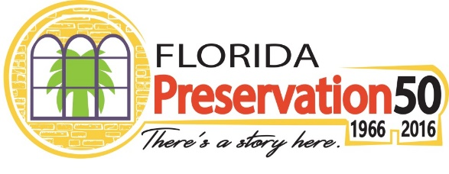

Preservation50 is a national initiative celebrating the 50th anniversary of the signing of the National Historic Preservation Act on October 15, 1966, by President Lyndon B. Johnson. The Act laid the groundwork for programs and procedures that are fundamental to historic preservation efforts. These include the National Register of Historic Places, Certified Local Governments, Section 106 Review Process, the Advisory Council on Historic Preservation, and the Historic Preservation Fund. The Act also established state and tribal historic preservation programs.

In Florida, the Division of Historical Resources within the Florida Department of State is the State Historic Preservation Office (SHPO). The Division is responsible for conducting historic preservation programs, and has joined the national effort to recognize and celebrate the impact of the National Historic Preservation Act. The Division is using the Preservation50 platform as an opportunity to showcase ways in which the Division and our partners work year-round to promote and protect Florida’s historic places.

Throughout the next year, the Florida Division of Historical Resources invites Florida Main Streets to join us in this national celebration of Preservation50 to shine a light on the past, present and future achievements of historic preservation. To learn more, visit flheritage.com/preservation50.

October 2016 is Florida Main Street Month!

Florida Main Streets are uniquely able to bring Florida’s culture and history to a wide audience. During the month of October, the Division of Historical Resources encourages our Florida Main Street Communities to get involved by branding your existing Main Street events with the Preservation50 title and logo.

The Division of Historical Resources will promote Main Street Month Events through press releases and online promotion. In addition, the Division will supply all of our 47 Main Street communities with Preservation50 drink coasters. These coasters can be distributed to restaurants within your Main Street districts to bring attention to the 50th Anniversary of the National Historic Preservation Act!

The Florida Division of Historical Resources presents a number of ways for partners to get involved and highlight Florida history and cultural heritage statewide. Please take a moment to explore how Florida Main Street may participate in this ongoing statewide promotion of the Preservation50 Initiative.

- Use the official Preservation50 logo – Visit flheritage.com/preservation50 to simply download the Preservation50 logo. The logo can be added to your event materials and your website, and you can link to the Preservation50 website. By connecting with this brand, your organization will benefit from association with this statewide campaign to raise awareness of Florida’s preservation efforts and its diverse history and cultural heritage.

- Submit your event information to the official Preservation50 website – This is an easy way to gain recognition for events you are already planning and branding as Preservation50 events. Events may be shared on the Division of Historical Resources and Main Street Facebook pages or added to the featured events on flheritage.com/preservation50. Submit your event by emailing Florida Main Street staff at floridamainstreet@dos.myflorida.com.

- Connect via Social Media – both at the state and local levels using #Preservation50. Connect your Preservation50 branded events and ask participants to like, follow, and post pictures and videos. Be sure to connect with and continue to tag, trend and talk about Preservation50 through current social media sites including Facebook.com/FloridaMainStreet, Instagram.com/FloridaMainStreet, and Facebook.com/FloridaDivisionofHistoricalResources.

- Promote to the media and cross-promote local Preservation50 partners - Promote your local Main Street activities and events to media contacts including TV, radio, newspapers, local blog and magazine reporters, news desks and editors to make them aware of your program; always include a call-to-action and a way to learn more, such as a website, while you also cross-promote other local preservation partners to leverage word-of-mouth advertising throughout the community, county and region.

- Send your press releases or promotional videos – by emailing your press releases to Florida Main Street staff at floridamainstreet@dos.myflorida.com, the Division of Historical Resources can also feature your photos and videos on social media pages, and may post information about your institution and events on Preservation50 website. We encourage media to visit this page to find out more about statewide events and activities.

- Consider including traditional artists from your area – Contact State Folklorist, Amanda Hardeman, at 850.245.6427 or Amanda.Hardeman@dos.myflorida.com for referrals to performers and/or traditional artists who reflect the heritage and cultural diversity of your community. Or, you could reserve a knowledgeable speaker from The Florida Humanities Council, which has an outstanding Speakers Bureau and various educational resources at FloridaHumanities.org.

